North American Baptist Heritage Commission
Church Histories

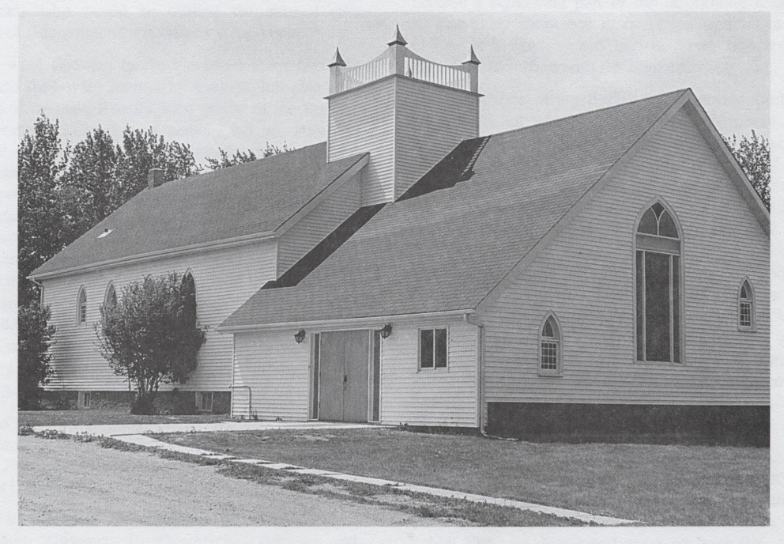
Church with extension – 1980’s

Rabbit Hill Church, Leduc County, Alberta

The Rabbit Hill Baptist Church, which had its beginning in 1892, was first known as the Heimthal German Baptist Church. The first meetings were in the homes of these German settlers. The church was officially organized with 17 charter members. In one year the membership increased to 89. Soon it was decided to build a church building on land which had been donated. This was the first North American Baptist church in the Canadian Northwest. Dedicated in 1896 at a total cost of $600, the church was built of hand-hewn lumber with donated materials and labor. After a few years, the name of the church was changed to Otoskewin Baptist Church. In 1921 at the 25th anniversary, the name was once again changed to Rabbit Hill Baptist Church.

In 1940 a new building was erected. By 1946, all services were in the English language. In 1980 a parsonage was built on the church property. A Sunday School, a Ladies’ Mission Circle, and a summer Daily Vacation Bible School soon became a part of the outreach of the church. Rabbit Hill Baptist Church was the mother to seven other churches in the Edmonton area. The church celebrated its 100th anniversary in 1991.

Written by Phyllis Harms, NAB Heritage Commission [March, 2016]

Bibliographical sources:
Stark, Loren. “Rabbit Hill Baptist Church.” Leduc History Book: 1995.
Stelter, Gladys. “Begun in 1880s, Church is Still Growing.” Baptist Herald, July/August 1983.

Archival sources in North American Baptist Heritage Center:

Additional pictures
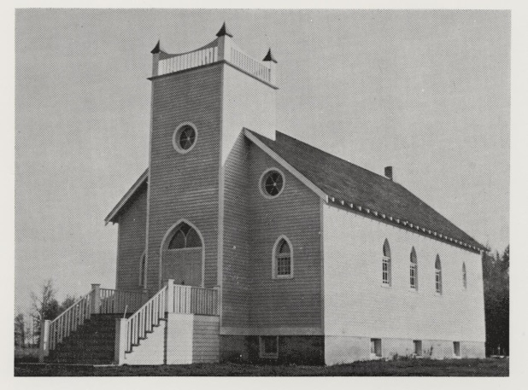
Built in 1940

